GroundcrewAI Stage 6.3

- Let us go back to the “Verify Email” topic that we have already created

- Add a node below the adaptive card, “Add a tool > “Genrate OTP” flow that we have just created
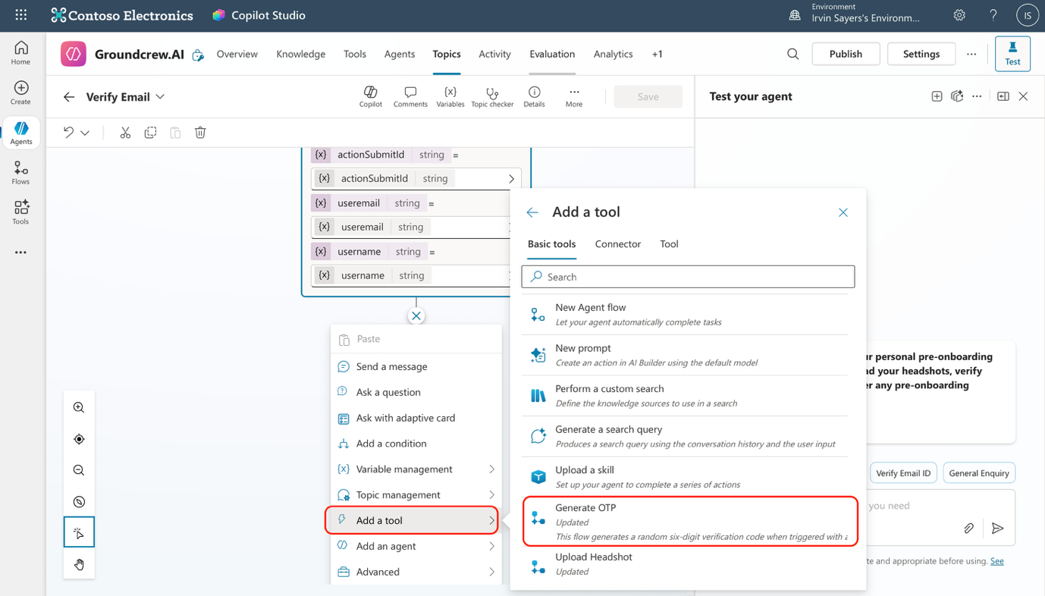

- In the inputs select the “username” and “useremail” variables that we will get from the adaptive cards
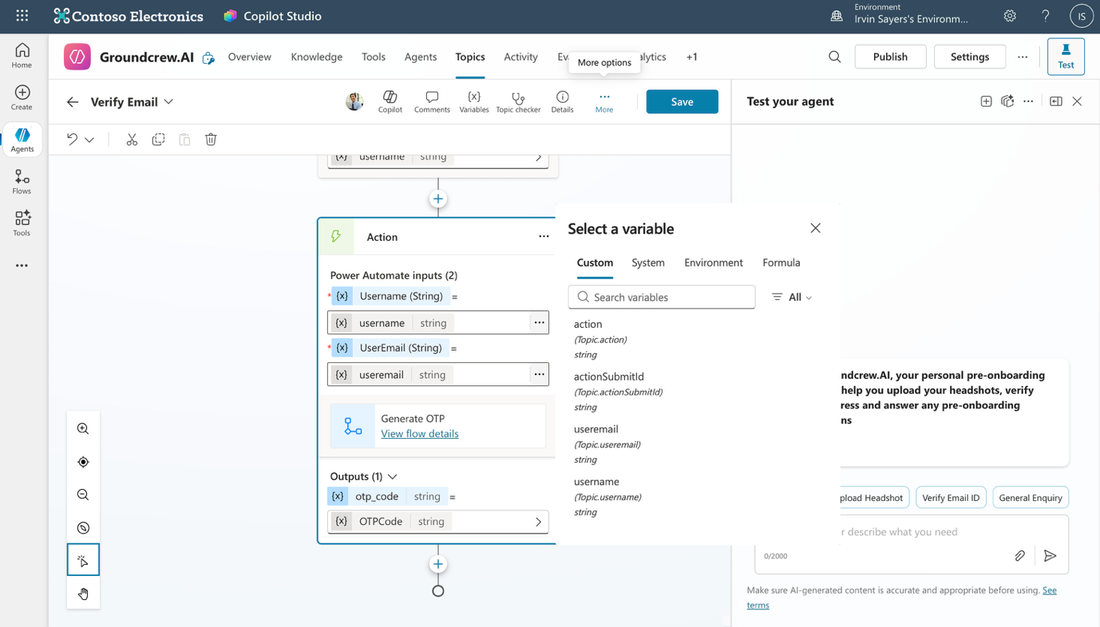

- Add another card node and copy this code into the card editor as you have done previously.

{
"$schema": "http://adaptivecards.io/schemas/adaptive-card.json",
"type": "AdaptiveCard",
"version": "1.5",
"body": [
{
"type": "Container",
"style": "emphasis",
"bleed": true,
"items": [
{
"type": "TextBlock",
"text": "🔐 Enter Your OTP",
"weight": "Bolder",
"size": "Large",
"color": "Accent",
"horizontalAlignment": "Center"
},
{
"type": "TextBlock",
"text": "We’ve sent a one-time passcode to your email. Please enter it below to continue ✨",
"wrap": true,
"spacing": "Small",
"horizontalAlignment": "Center"
}
]
},
{
"type": "Container",
"style": "default",
"bleed": true,
"items": [
{
"type": "TextBlock",
"text": "📲 One-Time Passcode (OTP)",
"weight": "Bolder",
"spacing": "Medium"
},
{
"type": "Input.Text",
"id": "otp",
"placeholder": "Enter your 6-digit code",
"maxLength": 6
}
]
}
],
"actions": [
{
"type": "Action.Submit",
"title": "Verify OTP ✅",
"data": {
"action": "verifyOtp"
}
}
]
}

- You should see an adaptive card with 3 outputs like this
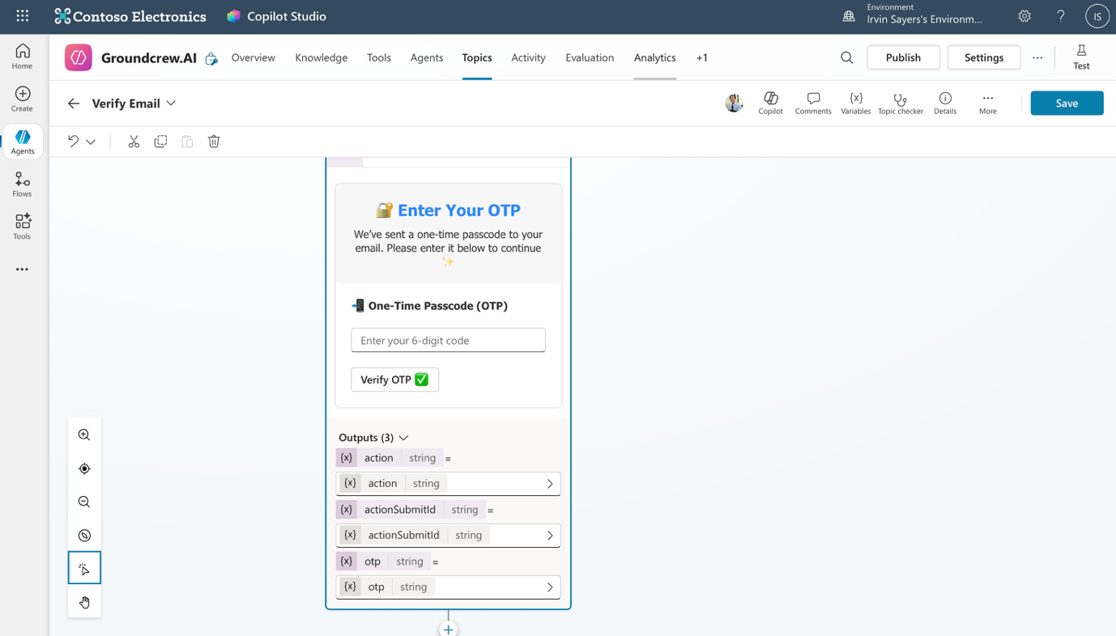

- Let’s add a condition node below the adaptive card. For the first condition select the “otp” variable that user will input to adaptive card and the middle box should contain “Is equal to” then selct the value “OTPCode” which the flow will be giving us as an output. This will verify the OTP.

- Below the “Condition” node with your condition, press the “+” button and add a message, “Your Email has been successfully verified!” then add another node “Topic management > go to another topic > conversation start”
Below the “All other condition node” add a “message’ node with a message “Verification failed” and add another node “Topic management > go to another topic > verify email”
Your conditions should look like this, save the topic now.
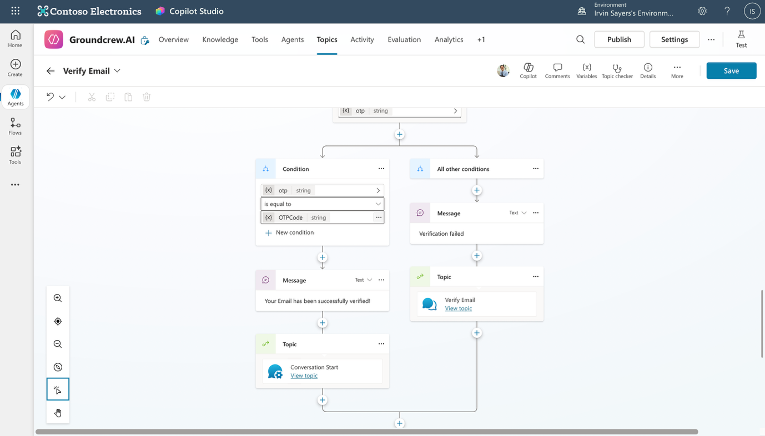

- Now we have to go back to our conversation start topic on the system topics. Under the condition, “Var 1 is equal to “Verify Email ID” lets add a node “Topic management > Go to another topic > Verify Email”
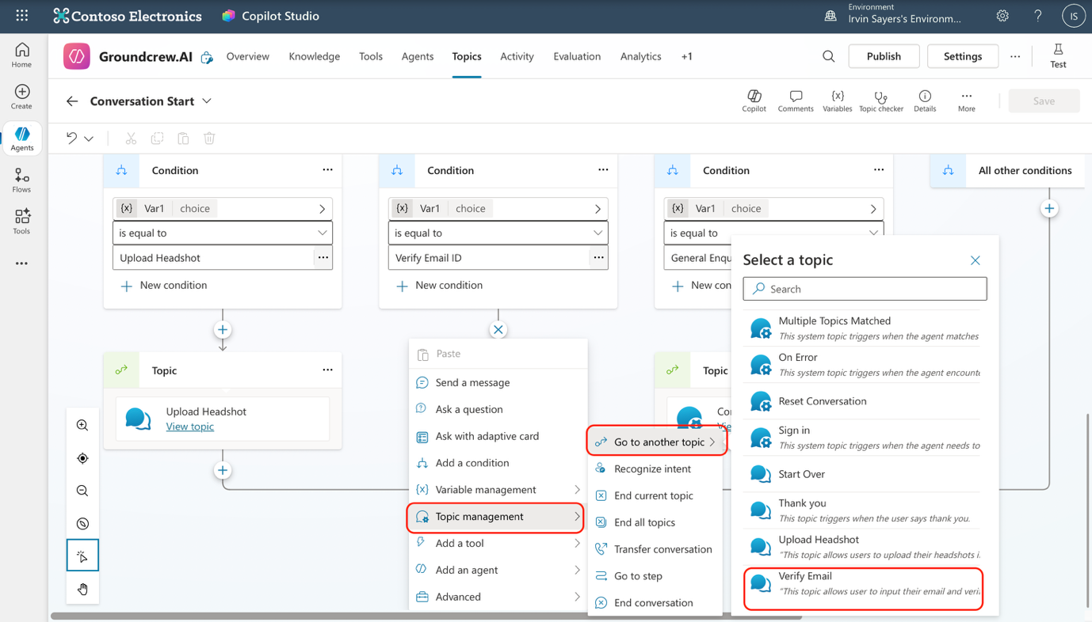
9. Congratulations! You just integrated the flow to the topic and completed the process to verify email ID!

